Haley Eakin

9/12/18

Homework #1

Nomadic Matt Travel Blog

www.nomadicmatt.com

Nomadic Matt is a travel blog site that features guidebooks about travel destinations as well as travel resources and information from the perspective of an individual who has backpacked the world extensively. The purpose of this website is to provide users with information about how to travel well and cheaply. The audience of the Nomadic Matt website are travelers and people interested in traveling as the website content is geared towards both people who are planning trips and people who are currently traveling. The Nomadic Matt website is a reliable and trustworthy resource since is updated frequently to include current and relevant information on costs, best places to visit, world events, and new places that Matt has traveled to. Examples of Good Web Design:

1. Great Usability: The Nomadic Matt website has great usability. Navigating the website came intuitively and without effort since there are multiple, straightforward avenues to accessing content. The menu with dropdowns across the top of the website that users can use to navigate to different components of the website like the about page, blog, destination guides, resources, and more.

Search bar is visible and in a standard position on the page, making it easy to find and use. In addition, it produces relevant results.

The menu at the top of the page provides helpful categorization of content with dropdowns menus for further navigation.

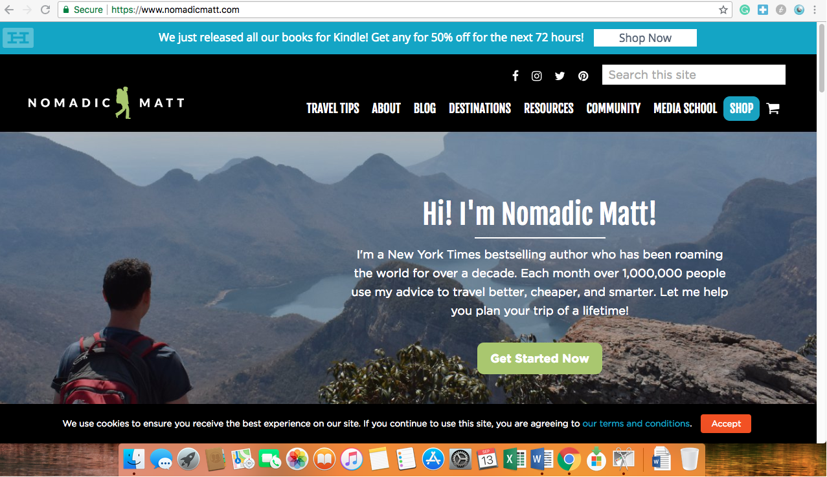

1. Targeted to Audience Needs: The audience for this website is travelers and people interested in traveling. I believe the website performs exceptionally being usable and engaging to many different kinds of travelers. The website does well at providing meaningful information to subcategories of their travel audience, including content that directed towards budget travelers, LGBTQ travelers, women travelers, and more. This information is located throughout many areas of the blog including the blog posts, travel tips, and destination guide sections of the website so that these users can easily find relevant information to them. In addition, this website serves both frequent and new users well. While the search navigation bars and menus provide users with the tools needed to find the information they want fast, the landing pages includes clickable previews of top content such as “Most Requested Travel Advice” and “Latest Blog Posts” to drive new users that are not exactly sure of what they are looking for to content that will most likely interest them.

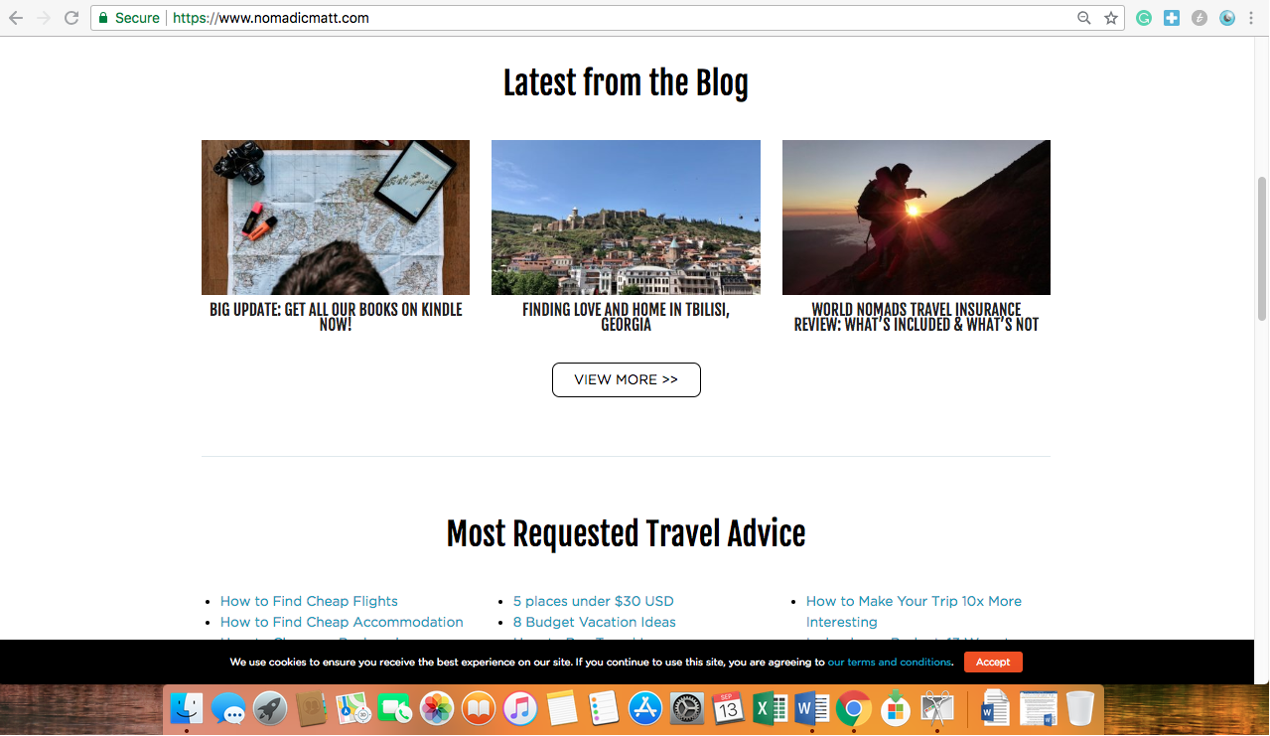

1. Dynamic Sizing: The website automatically resizes itself to fit the screens of a phone or computer, which is a great feature of its designs.

When the website resizes to fit a smaller screen, the menu that was previously across the top of the screen becomes a hamburger menu that stills allows for simple and easy navigation.

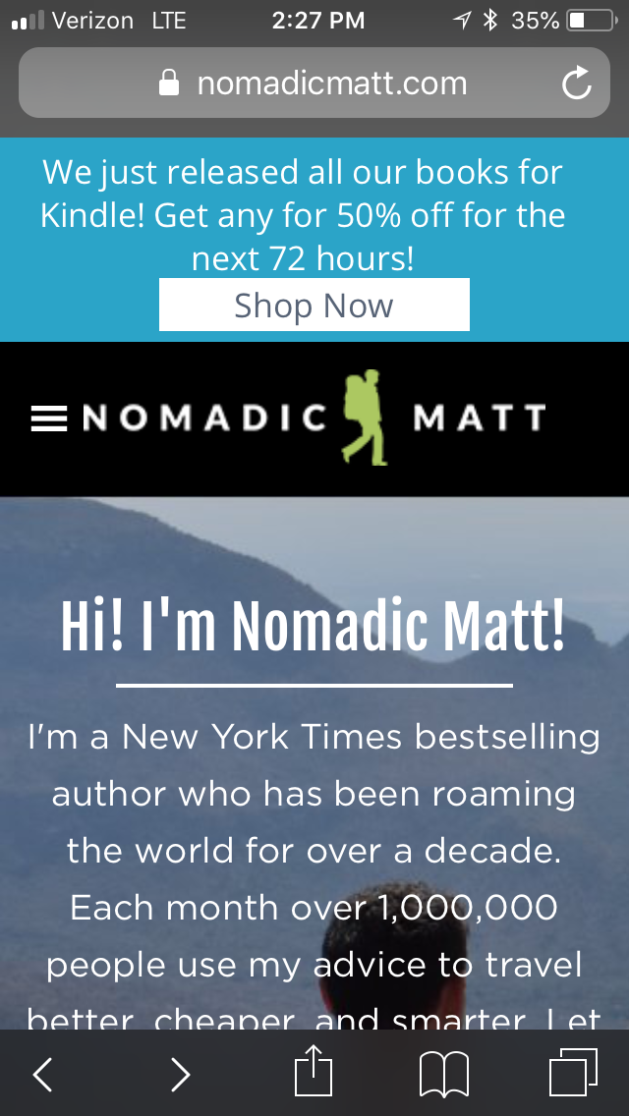

1. Good Feedback: The Nomadic Matt website provides good feedback to users. I never felt lost on the website because each time I searched for a specific piece of information, I was provided with feedback on each page that reassured me that I was getting closer to accessing the information I wanted or needed to reroute. For example, if I wanted view information about traveling in Cambodia, I clicked on the “Destinations” in the menu, which brought me to a page titled “Travel Guides” with an interactive map of the world underneath. By receiving this feedback, I was able to quickly figure out that by clicking on Cambodia in the map I would access a travel guide for Cambodia. The Furthermore, the Nomadic Matt website is responsive. Unlike similar travel websites I have used, this site loads quickly and reliably. All the links I tested are working properly and delivered me to useful information.

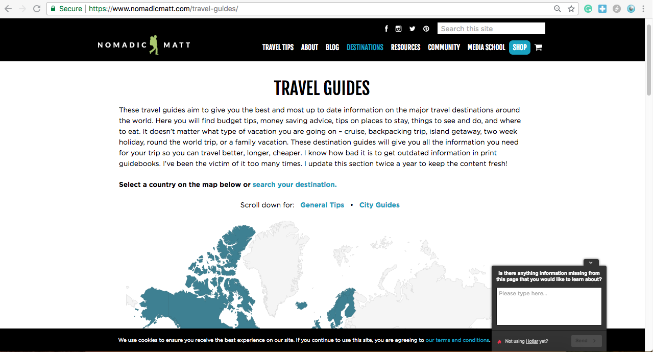

1. Visually pleasing aesthetic: The website looks nice and uses cohesive colors and branding imagery. Also, the fonts used are easy to read and coherent. The nice visual design of the website contributes to its usability and my enjoyment of the website.

Re-Design Ideas:

Although I find this website to be very user-friendly and well-designed, there is areas of the website that could use improvement. For example, I would include rotating images or even a video on the website landing page where the photo banner currently resides. Secondly, because the webpage hosts extensive blog content, I would change the “Latest from the Blog” section to have a slider so that users can easily view more blog posts. Furthermore, currently the “Most Requested Travel Advice” section on the landing page looks quite cluttered since it just a section of hyperlinked titles. I would re-design this section into categories, so that users could easily find the content the interests them most.

Blog posts section would include a slider to display more content and increase user interaction with the webpage.

This banner would include rotating images to improve the visual appeal of the webpage.

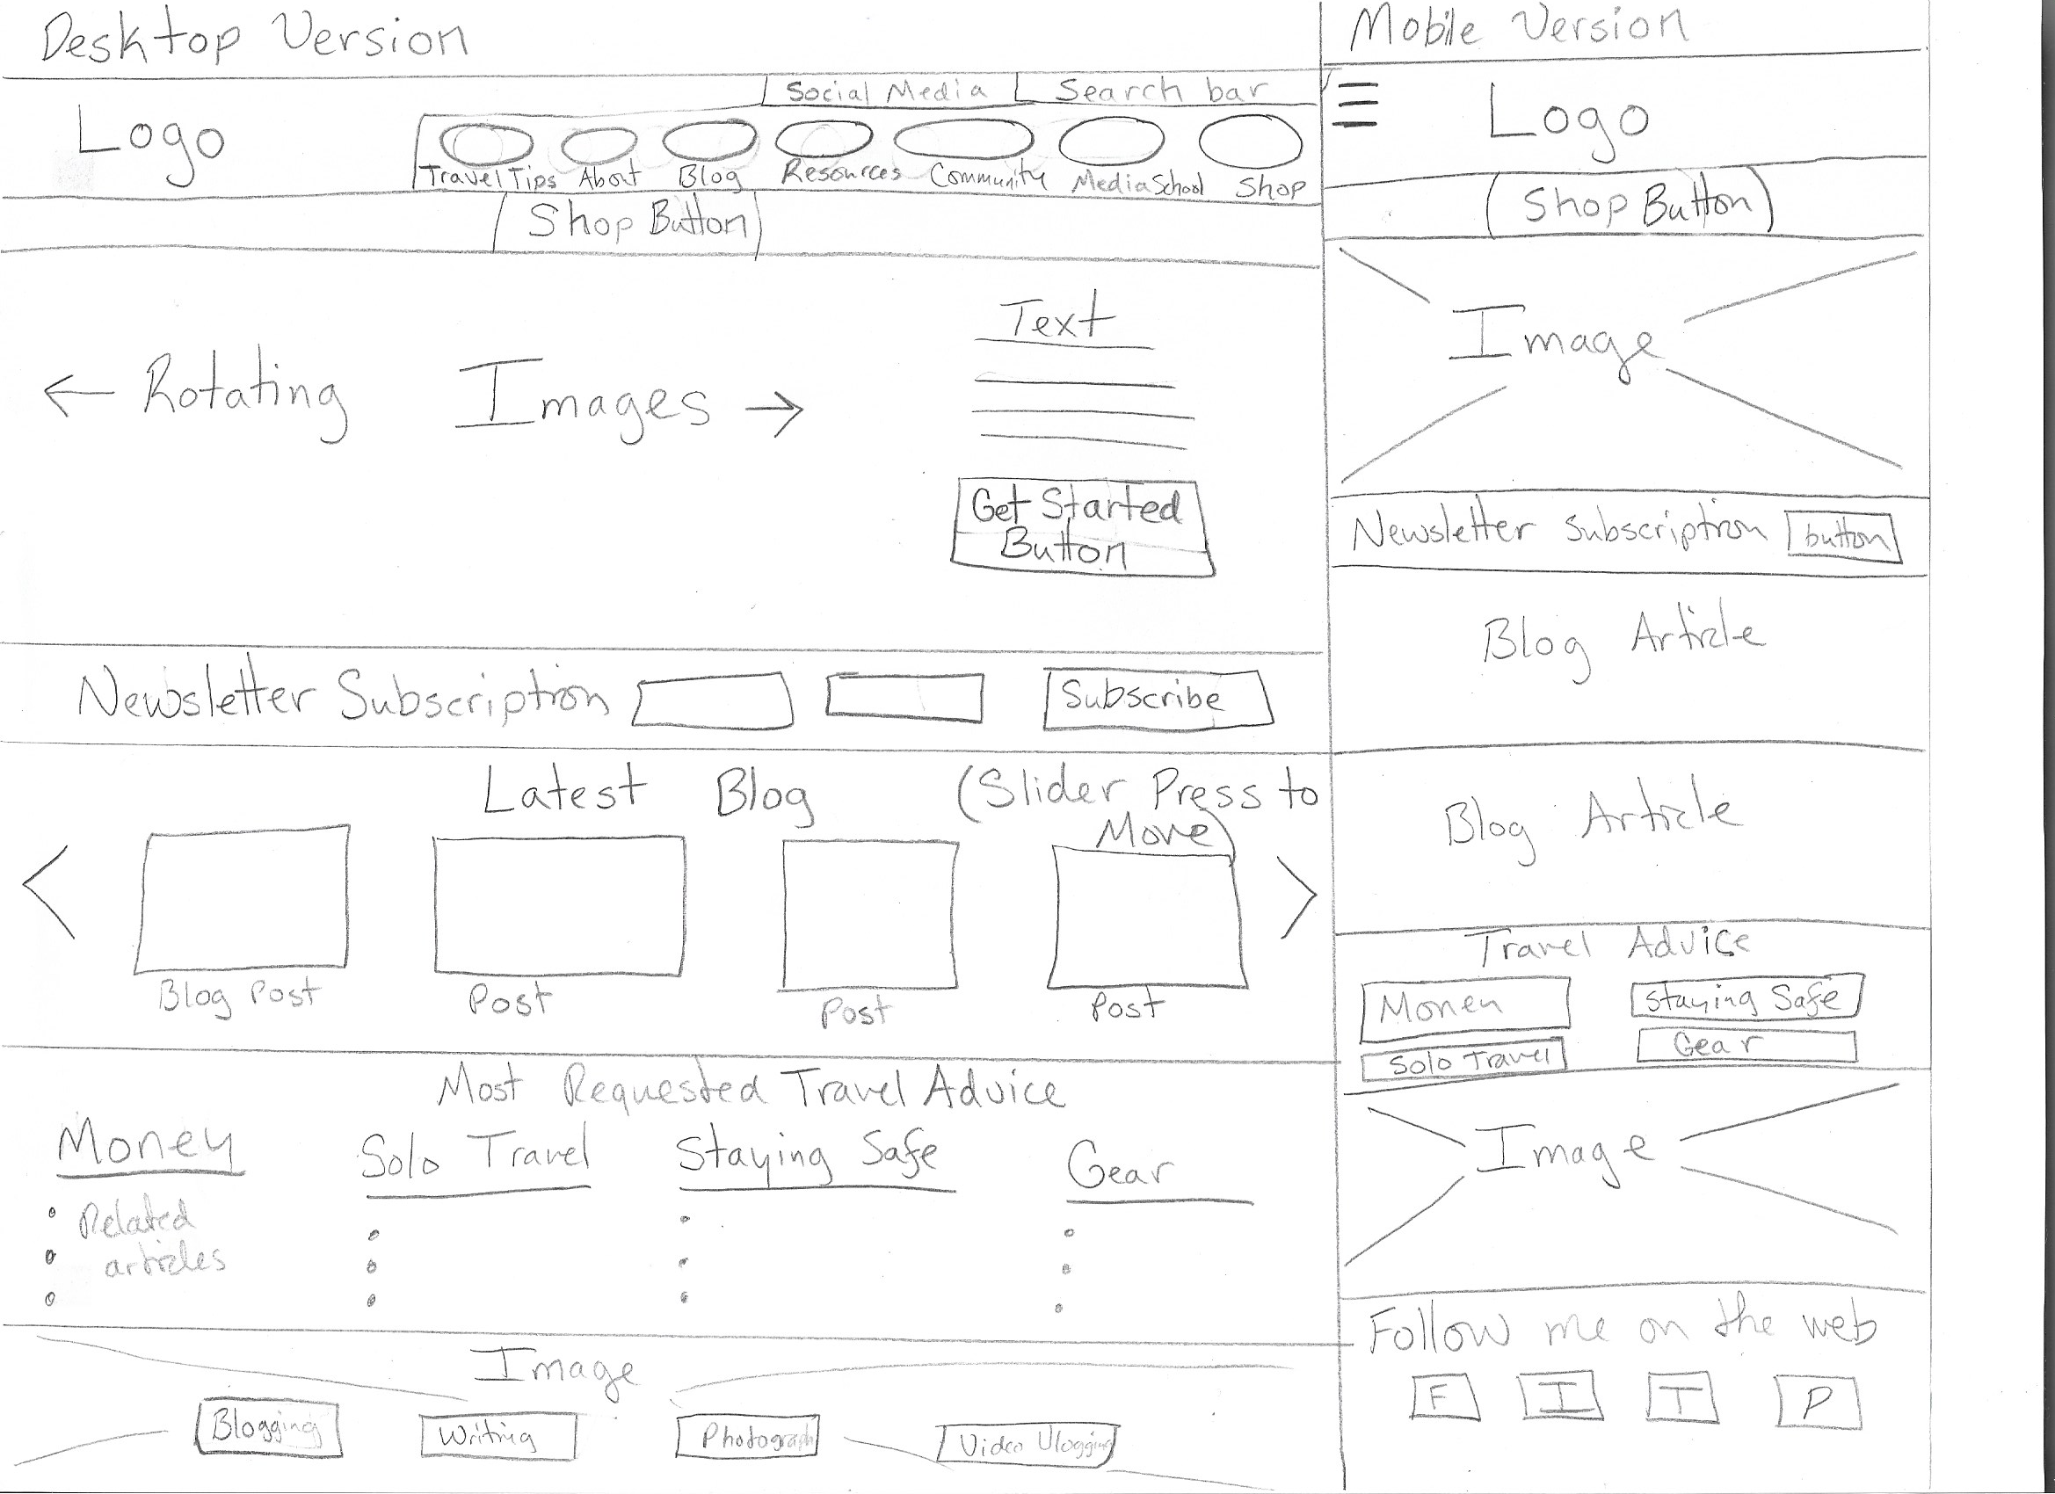

This section would be broken down into categories to improve ease of navigation and declutter this area of the landing page.

Jeannette Rankin Peace Center

[www.jrpc.org](http://www.jrpc.org)

This is a website for the local nonprofit, the Jeannette Rankin Peace Center. The audience of this website is Missoula community members who are members of center or are interested in the center’s work. The purpose of the website is to provide people involved or interested in the Jeannette Rankin Peace Center with upcoming events, news, and resources related to the center’s work. Although I appreciate this nonprofit and want to follow their work, I find their website very difficult to navigate and gather information from.

Examples of Poor Web Design:

1. Lack of Navigation Ease: This site is challenging to navigate. It does not have the customary search bar in the top right corner or anywhere else on the website. With no search bar, one is left to click around the website to find the information they are seeking. Although there is a tab menu with drop downs, the drop downs are labeled in a vague and confusing manner. For example, when you scroll over “Act” in the menu bar, there are two options “Contacts” or “Links,” which are vague pieces of feedback that do not help me to access the information I seek.

This is landing page of the JRPC website. There is no search bar to be found here on anywhere on the website.

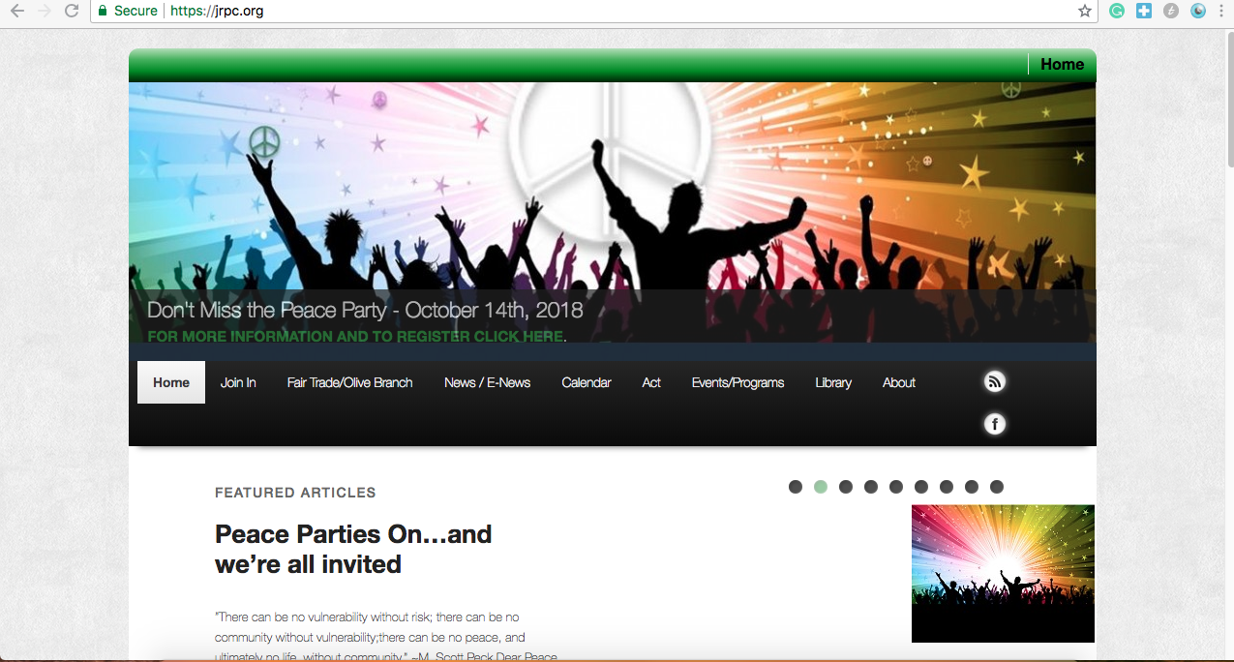

1. Abrasive and Outdated Visual Design: The website looks outdated and boring. Furthermore, there is no logo or the name of the organization on the website landing page. There is a lack of color and innovative in the visual design of the site. Although there is a consistent use of green color, the website lacks branding cohesion. In addition, many of the pictures are of poor quality or are outdated stock images.
2. Lack of Dynamic Sizing: The website glitches when trying to readjust to screen sizes such as phone. When not on a standard laptop or desktop computer, parts of the website start to malfunction and overlap each other. For example, when using an Iphone to view the website, circles overlapped the “Featured Articles” heading.

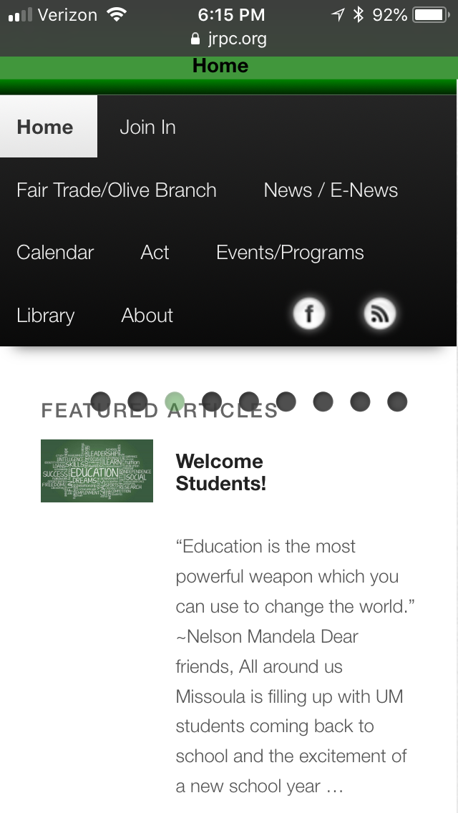

1. Poor feedback: The vague names on menu bar items and drop-down menus result in poor feedback for the user. I often did not know what I would end up on when clicking through the website and the headers and titles often did not help orient me and provide useful feedback.

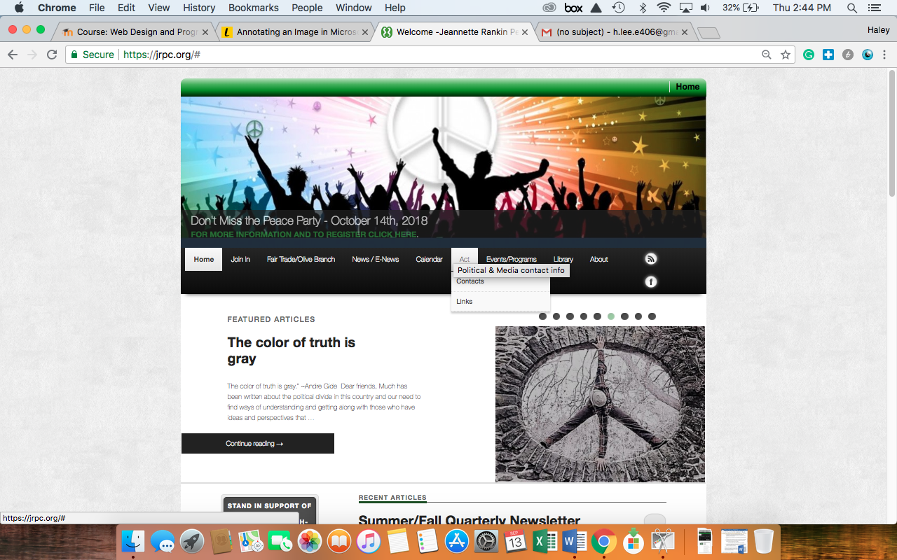

1. Poor Use of Screen Real Estate: The JRPC website poorly uses its screen real estate, particularly on the landing page. When landing on the page, a user can only see the banner, menu, and portion of the “Featured Article” section. When scrolling down, there is a large, blank spot completely unused. This is prime real estate on the website and should definitely be optimized.

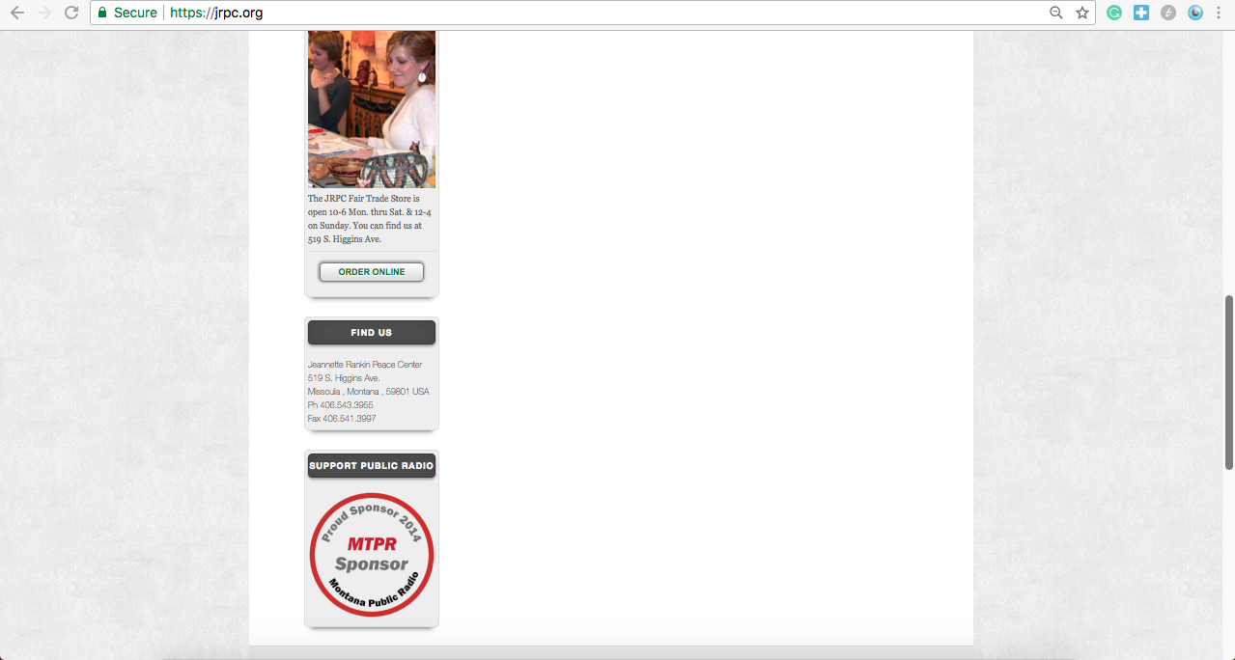

Re-design Ideas:

To make the Jeannette Rankin Peace Center’s website more usable, I would change the layout of the landing page, labels, and sizing of the webpage. Firstly, I would change the visual aesthetic to liven up the website by updating photos and including the using of color. Secondly, I would change the sizing of the page so that the website content filled the screen to eliminate the underutilized on the sides of screen and on the landing page as shown in the example above. To ensure the website was more user friendly to mobile phones and desktops, I would also make the site dynamically sized. Lastly, I would change the labels menu and dropdowns and add a search bar to improve navigation. Below is a sketch of my re-design.

Included the organization’s name and logo at the top of the page to promote brand identity and improve feedback.

Added “shop” and “donate” buttons to the landing page to promote these actions.

Added a search bar in the top right corner of the website and altered the label name on the menu bar.

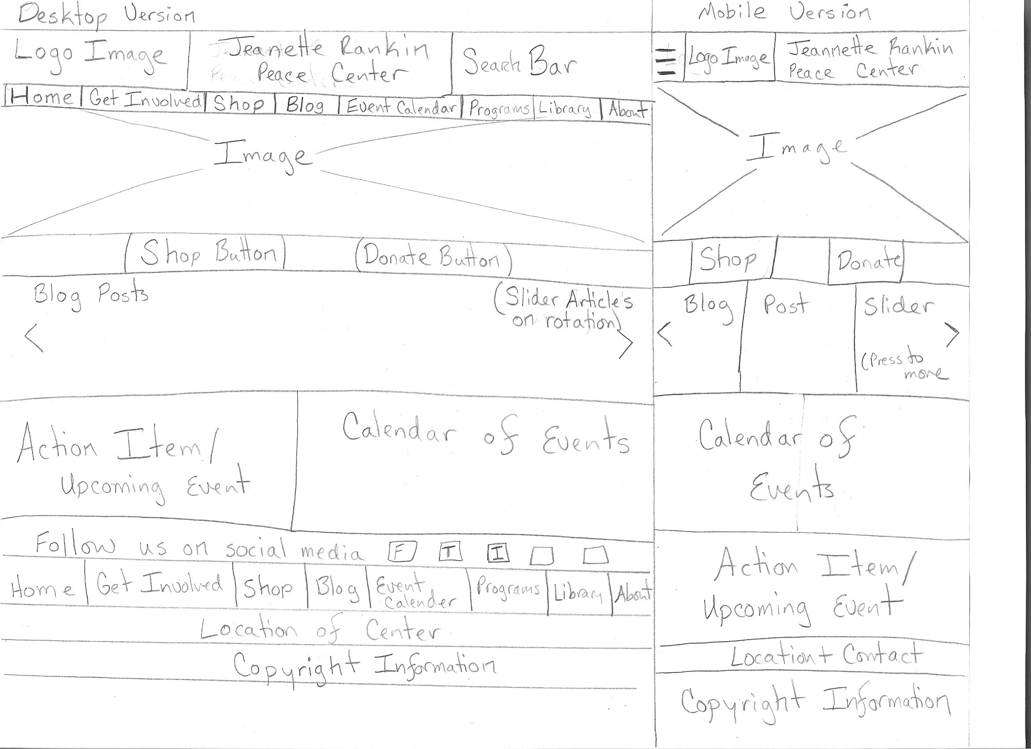

To eliminate the unused space on the landing page, I added two blocks for an event calendar and call to action.

Added a slider bar for blog posts so that top content could be highlighted on the landing page.